Smart Building

Submitted by – ISHAN DANGI

INRODUCTION

* 1. OVERVIEW

The smart building project integrates relays to wirelessly control LEDs through a mobile app. Using a microcontroller and communication module, each LED zone is assigned a relay for individual or group control. The mobile app, designed for both Android and iOS, offers features such as on/off toggling, dimming, and scheduling. Security measures are implemented to ensure protected communication, while energy efficiency is enhanced with automatic shutoff and sensor integration. This project aims to deliver a user-friendly and sustainable smart lighting solution for modern living.

## PURPOSE

The purpose of the smart building project is to provide users with seamless and efficient control over lighting systems through wireless technology. By integrating relays and a microcontroller, the project enables the remote management of LEDs via a dedicated mobile app, enhancing user convenience and flexibility. The system's key objectives include individual and group control of LEDs, real-time status feedback, and the implementation of energy-saving features. Ultimately, the project strives to create a smart building environment that prioritizes user experience, security, and sustainability, offering a modern and accessible solution for intelligent lighting management.

LITERATURE SURVEY

2.1 EXISTING PROBLEM

Although we have advanced in automation to a considerable extent, we still lack in automating the civilian residents. A lot of energy is being wasted because of unnecessary usage of devices in homes and industries. In a big household people often forget to turn off appliances which leads to wastage of energy and increment in bills. Also, there is not any advancement in technologies that can be used to manipulate home appliances from distance and manage things.

## 2.2 PROPOSED SOLUTION

We need to normalise the automation of homes and make people be more comfortable to this technology. Controlling home appliances remotely with a mobile will make it easy to control home appliances and save energy by turning off unnecessary devices from anywhere. This will save energy, reduce bills, and increase life of electronic devices.

THEORITICAL ANALYSIS

3.1 HARDWARE / SOFTWARE DESIGN

We used following hardware components-

**ESP32**- The ESP32 is a versatile and powerful microcontroller that integrates Wi-Fi and Bluetooth capabilities, making it ideal for a wide range of IoT applications. Developed by Espresso Systems, the ESP32 offers dual-core processing, low-power modes, and a rich set of peripherals, making it suitable for projects requiring wireless connectivity and advanced functionality. Its popularity stems from its affordability, community support, and compatibility with the Arduino IDE, making it a popular choice for developers and hobbyists alike.

**Relay-** Relays are electromechanical switches that control high-power electrical devices using a low-power input. They consist of a coil, an armature, and a set of contacts, allowing them to open or close circuits based on an external signal. Widely used in automation, relays play a crucial role in applications such as home automation, industrial control systems, and smart building projects, enabling remote or automated control of electrical appliances.

LED’s

DHT22 sensor

Bread board

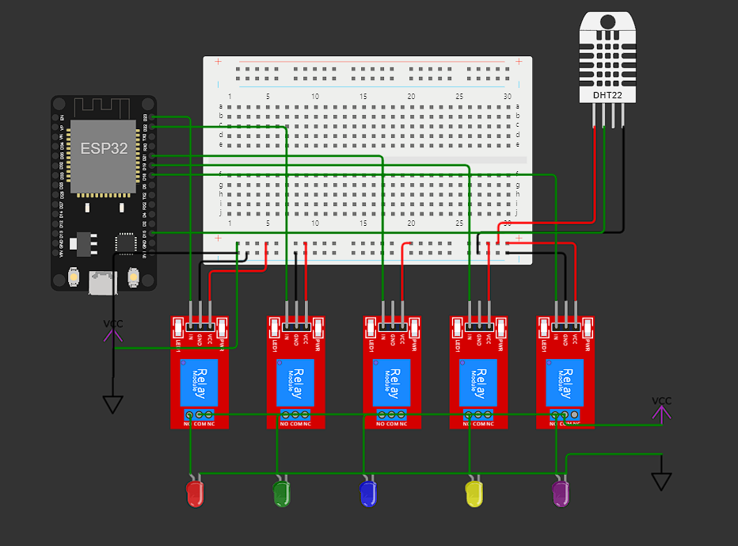Wires

# CONNECTIONS

CODE

#define BLYNK_TEMPLATE_ID "TMPL3Z95WqhwN"

#define BLYNK_TEMPLATE_NAME "Smart building virtual"

#define BLYNK_AUTH_TOKEN "dTrM9IO4-0VOnxf6JZ0BfIf5J1G6oU0W"

#define BLYNK_PRINT **Serial**

#include <WiFi.h>

#include <WiFiClient.h>

#include <BlynkSimpleEsp32.h>

#include "DHTesp.h"

char auth[] = BLYNK_AUTH_TOKEN;

char ssid[] = "Wokwi-GUEST";

char pass[] = "";

BlynkTimer timer;

DHTesp dhtSensor;

const int dev1 = 23;

const int dev2 = 22;

const int dev3 = 21;

const int dev4 = 19;

const int dev5 = 18;

//this is for DHT Sensor

const int dht = 15;

int relay_s_dev1 = 0;

int relay_s_dev2 = 0;

int relay_s_dev3 = 0;

int relay_s_dev4 = 0;

int relay_s_dev5 = 0;

#define vpin1 V1

#define vpin2 V2

#define vpin3 V3

#define vpin4 V4

#define vpin5 V5

BLYNK_CONNECTED() {

  Blynk.syncVirtual(vpin1);

  Blynk.syncVirtual(vpin2);

  Blynk.syncVirtual(vpin3);

  Blynk.syncVirtual(vpin4);

  Blynk.syncVirtual(vpin5);

}

BLYNK_WRITE(vpin1) {

  relay_s_dev1 = param.asInt();

  digitalWrite(dev1, relay_s_dev1);

}

BLYNK_WRITE(vpin2) {

  relay_s_dev2 = param.asInt();

  digitalWrite(dev2, relay_s_dev2);

}

BLYNK_WRITE(vpin3) {

  relay_s_dev3 = param.asInt();

  digitalWrite(dev3, relay_s_dev3);

}

BLYNK_WRITE(vpin4) {

  relay_s_dev4 = param.asInt();

  digitalWrite(dev4, relay_s_dev4);

}

BLYNK_WRITE(vpin5) {

  relay_s_dev5 = param.asInt();

  digitalWrite(dev5, relay_s_dev5);

}

void send_dht_val() {

  TempAndHumidity  data = dhtSensor.getTempAndHumidity();

  float temp = data.temperature;

  Blynk.virtualWrite(V8, temp);

}

void setup () {

  pinMode(dev1, OUTPUT);

  pinMode(dev2, OUTPUT);

  pinMode(dev3, OUTPUT);

  pinMode(dev4, OUTPUT);

  pinMode(dev5, OUTPUT);

  //to start serial print

**Serial**.begin(115200);

  //This is for the starting check for the led

  digitalWrite(dev1, HIGH);

  digitalWrite(dev2, HIGH);

  digitalWrite(dev3, HIGH);

  digitalWrite(dev4, HIGH);

  digitalWrite(dev5, HIGH);

  delay(1000);

  digitalWrite(dev1, LOW);

  digitalWrite(dev2, LOW);

  digitalWrite(dev3, LOW);

  digitalWrite(dev4, LOW);

  digitalWrite(dev5, LOW);

  delay(1000);

  Blynk.begin(auth, ssid, pass);

}

void controlButton(int relayIn) {

  if (relayIn == 1) {

    relay_s_dev1 = !relay_s_dev1;

    digitalWrite(dev1, relay_s_dev1);

    delay(100);

  }

  if (relayIn == 2) {

  relay_s_dev2 = !relay_s_dev2;

  digitalWrite(dev2, relay_s_dev2);

  delay(100);

  }

}

void loop () {

  Blynk.run();

  timer.run();

  timer.setInterval(2000, send_dht_val);

}

# PRACTICAL IMPLIMENTATION

Video Link

<https://drive.google.com/file/d/1cXouTy5-Tok8Mry1uPqPE-Ag-VdzQP_y/view?usp=drive_link>

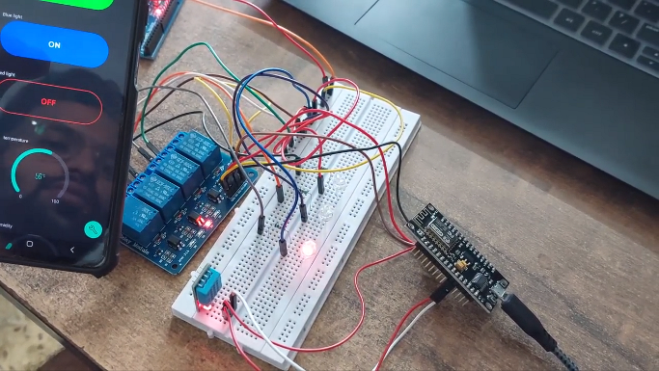

## ADVANTAGES AND DISADVANTSGES

**Advantages of Smart Buildings:**

1. **Energy Efficiency:** Smart buildings employ advanced technologies to optimize energy consumption through automated lighting, heating, and cooling systems, resulting in reduced energy costs and environmental impact.
2. **Cost Savings:** Long-term operational cost savings are possible as smart building systems can efficiently manage resources, predict maintenance needs, and extend the lifespan of equipment through data-driven insights.
3. **Enhanced Comfort and Productivity:** Intelligent climate control, lighting, and environmental monitoring contribute to improved occupant comfort and well-being, leading to increased productivity and satisfaction among building occupants.
4. **Remote Monitoring and Control:** Facility managers can remotely monitor and control various aspects of a smart building, enabling quick responses to issues, preventive maintenance, and efficient resource allocation.
5. **Sustainability:** Smart buildings often incorporate sustainable practices and technologies, contributing to reduced waste, lower carbon footprints, and alignment with green building standards.

**Disadvantages of Smart Buildings:**

1. **High Initial Costs:** The upfront costs of implementing smart building technologies, including sensors, automation systems, and connectivity infrastructure, can be significant, posing a barrier to adoption for some organizations.
2. **Complex Integration:** Integrating diverse systems and devices within a smart building, such as HVAC, lighting, security, and IoT devices, can be complex and may require careful planning to ensure seamless interoperability.
3. **Security Concerns:** The interconnected nature of smart building systems introduces cybersecurity risks, including potential breaches, data privacy issues, and the risk of unauthorized access to critical infrastructure.
4. **Technological Obsolescence:** Rapid advancements in technology may result in the obsolescence of certain components or systems, necessitating regular updates and investments to stay current with the latest innovations.
5. **Dependency on Infrastructure:** Smart buildings depend on robust and reliable digital infrastructure, including high-speed internet connectivity and power sources. Any disruptions to these services may impact the functionality of smart systems.

# APPLICATIONS

Smart buildings find applications across various sectors, contributing to efficiency, sustainability, and enhanced user experiences. Some notable applications include:

1. **Commercial Buildings:**
   * **Office Spaces:** Automation of lighting, HVAC, and security systems for energy efficiency and improved workspace comfort.
   * **Retail Spaces:** Smart lighting, signage, and security systems to enhance the shopping experience.
2. **Residential Buildings:**
   * **Smart Homes:** Integration of smart thermostats, lighting, security cameras, and home automation for enhanced comfort, security, and energy efficiency.
3. **Healthcare Facilities:**
   * **Hospitals:** Smart building systems for patient room control, energy efficiency, and monitoring of medical equipment.
4. **Education Institutions:**
   * **Schools and Universities:** Automated climate control, lighting, and security systems for energy savings and improved safety.
5. **Hospitality Industry:**
   * **Hotels:** Smart room controls, energy management, and guest experience enhancements through automation and connectivity.
6. **Industrial Facilities:**
   * **Manufacturing Plants:** Monitoring and control of equipment, lighting, and HVAC systems for energy efficiency and production optimization.
7. **Government Buildings:**
   * **Public Offices:** Implementation of smart systems for efficient resource management, security, and cost savings.
8. **Transportation Hubs:**
   * **Airports and Train Stations:** Smart building solutions for efficient lighting, climate control, and security, as well as passenger information systems.
9. **Data Centres:**
   * **Server Facilities:** Smart building technologies for optimal temperature control, energy efficiency, and equipment monitoring.
10. **Sports Arenas and Entertainment Venues:**
    * **Stadiums:** Smart lighting, HVAC, and security systems for events, as well as enhanced fan experiences through connectivity.
11. **Cultural Institutions:**
    * **Museums and Galleries:** Climate control and lighting automation to preserve artifacts and provide an optimal viewing environment.
12. **Financial Institutions:**
    * **Banks:** Smart building solutions for security, energy efficiency, and climate control in branch locations.
13. **Agricultural Facilities:**
    * **Greenhouses:** Automated climate control, irrigation, and lighting for optimal crop growth.
14. **Research and Development Centres:**
    * **Laboratories:** Smart building systems to monitor and control environmental conditions for research integrity.

# CONCLUSION

In conclusion, the implementation of a smart building project represents a significant stride towards a more sustainable, efficient, and user-centric future. Through the integration of cutting-edge technologies, such as IoT devices, automation systems, and wireless controls, our project aims to redefine the traditional concept of buildings. By providing users with the ability to remotely manage lighting, climate, and security systems through a user-friendly mobile app, we aspire to enhance both convenience and energy efficiency. While challenges like cybersecurity and initial costs need careful consideration, the potential for long-term cost savings, improved occupant comfort, and a reduced environmental footprint underscores the transformative impact of smart building initiatives. In embracing this endeavour, we contribute to the evolution of modern living spaces into intelligent, responsive environments that prioritize the needs of occupants and pave the way for a more connected and sustainable future.